Leverage CRM — System Architecture & Tech Stack v1.0
Developer: Rao Humza Majeed
Date: 13/Oct/2025
Version: 1.0

System Overview
Leverage CRM is an integrated command center for Amazon wholesale sellers, designed to centralize outreach, supplier relations, operations, and profit tracking in one system.
The architecture enables automation, real-time analytics, and smooth Amazon SP-API integration.
Data Flow Description
The frontend communicates with the backend via REST APIs. Backend processes requests, applies business logic, and interacts with the PostgreSQL database. External APIs (Amazon SP-API, OpenAI, Gmail) integrate directly through secure endpoints to sync or generate data.

System Architecture Diagram
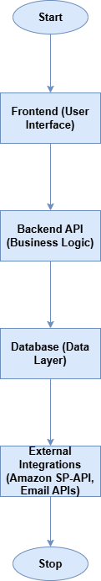

Tech Stack
Layer | Technology | Purpose
Frontend | React + Tailwind CSS | Fast, responsive, modern UI
Backend | Node.js (Express.js or NestJS) | REST APIs + scalable logic
Database | PostgreSQL | Relational DB for CRM data
ORM | Prisma ORM | Easier DB handling and schema migrations
Authentication | JWT (JSON Web Tokens) | Secure login system
AI Integration | OpenAI API / GPT | Outreach automation and message generation
Amazon Integration | Amazon SP-API | Data sync (sales, stock, refunds)
Email Sync | Gmail / Outlook APIs | Contact and communication sync
Deployment | AWS or Vercel | Hosting + scaling
Version Control | GitHub | Code management
Docs & Tracking | Notion + Loom | Internal documentation + video demos

Security & Auth
Authentication handled through JWT; HTTPS for all endpoints; environment variables managed securely using dotenv and AWS Secrets Manager.

